eBlessings International Daily Devotional Archives
enrich, inspire, encourage, bless, and empower spiritual warriors for end-time battles
prepared with the guidance of the Holy Spirit for spiritual growth and victory!
Devotionals Designed to Empower and Grow Our Spirits

SEPTEMBER2008SEPTEMBER2008SEPTEMBER2008
Visit DOT, and WOW Empowerment Series,
plus Prophecy, Spiritual Keys & Lessons, IA, PP and more...

Each One! Bless One!
You Make a Difference!

* * * * *

EXCERPT FROM IJAC?: IS JESUS A CRACKHEAD?

CHAPTER
16
(PART ONE)

Walking with Christ Jesus Daily

“Stand fast therefore in the liberty wherewith Christ hath made us free, and be not entangled again with the yoke of bondage. “
Galatians 5:1

Life is about not being bound by the Old Testament covenant, but being free in the New Testament covenant, Jesus Christ. Galatians 5:1 is quite appropriate for this chapter—not being tangled up with your old self, but in a new relationship in Christ.

satan. Words have power. Don’t give the enemies of God any power, any time, anywhere. Don’t give satan any respect. Don’t give him any time, not a moment.

Keep his name a lower case “s,” a little “s.” Because that is all he is, a little “h” (he, heathen), a little “s” (satan), and a little “d” (devil, demon). He walks around like a lion—not like a huge, powerful, beast of the wild (elephant, tiger, hippopotamus, or rhino), but he’s just a little cat; “meow, meow.” This is an exaggeration, but you get the picture.

The devil can do to you only what you allow him to do to you and what God allows him to do to you. Do not allow him to do anything to you or your family.

Heavenly Hierarchy. Let me share with you what the Holy Spirit shared with me about the Heavenly Hierarchy. This is powerful—do not ever forget this. In church one day, the Bishop of the church said that he was going to teach us how to be empowered in the LORD. He went on to say, “increase the amount you give in your tithes and offerings and you will be empowered.” My spirit knew that was not correct. So I asked Jesus to show me how to empower people and how to be empowered.

A few days later in my study of the Bible, the Holy Spirit directed me to this scripture:
“For we do not wrestle against flesh and blood, but against principalities, against powers, against the rulers of darkness of this age, against spiritual hosts of wickedness in heavenly places.”
Ephesians 6:12 (NKJV)

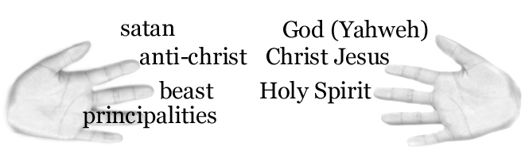 Spiritually, I focused on the Heavenly Hierarchy: Father God, Yahweh (the Creator of all), His Son, Christ Jesus, Emmanuel (Saviour of the world) and the Holy Ghost (the Comforter, the Holy Spirit of God). Then I thought about the opposite of that, the evil hierarchy (or evil lowerarchy): satan (leader of evil in the world) (Revelation 12:9), the antichrist (spirit of anti-Christ) (1 John 2:18, 4:30), and the beast (Revelation 11:7, 13:1) (representing world systems).

EXCERPT FROM IJAC? TO BE CONTINUED


James Anthony Allen Born-Again, Holy Ghost-filled, Tongue-speaking, Lion of Judah, Evangelist and US Patriot
http://www.eBlessings.us ; eBlessings@gmail.com
Stone Mountain, Georgia, USA, North America

