eBlessings International Daily Devotional Archives
FEBRUARY 2010 FEBRUARY 2010 FEBRUARY 2010

Each One! Bless One!
You Make a Difference!

* * * * *
THE LORD PROP US UP
Lord, prop us up on our leaning side, and we will forever give you the praise.

Every time I am asked to pray, I think of the old fellow who always prayed, “Lord, prop us up on our leanin' side.” After hearing him pray that prayer many times, someone asked him why he prayed that prayer so fervently.

He answered, “Well sir, you see, it's like this...I got an old barn out back. It has been there a long time; it has withstood a lot of weather; it has gone through a lot of storms, and it has stood for many years.

It's still standing. But one day I noticed it was leaning to one side a bit. So I went and got some pine poles and propped it up on its leaning side so it wouldn't fall. Then I got to thinking about that and how much I was like that old barn. I have been around a long time.

I've withstood a lot of life's storms. I've withstood a lot of bad weather in life, I've withstood a lot of hard times, and I'm still standing too. But I find myself leaning to one side from time to time, so I like to ask the Lord to prop us up on our leaning side, 'cause I figure a lot of us get to leaning at times.

Sometimes we get to leaning toward anger, leaning toward bitterness leaning toward hatred, leaning toward cussing, leaning toward a lot of things that we shouldn't. So we need to pray, “Lord, prop us up on our leaning side, so we will stand straight and tall again, to glorify the Lord.”
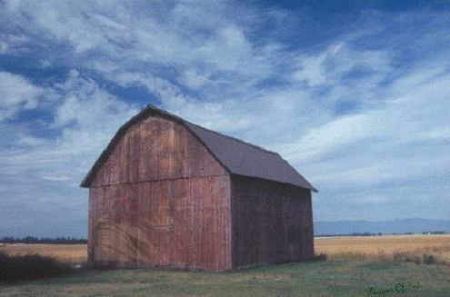
If you stare at this barn for a second you will see who will help us stand straight and tall again. Do You See HIM?!

